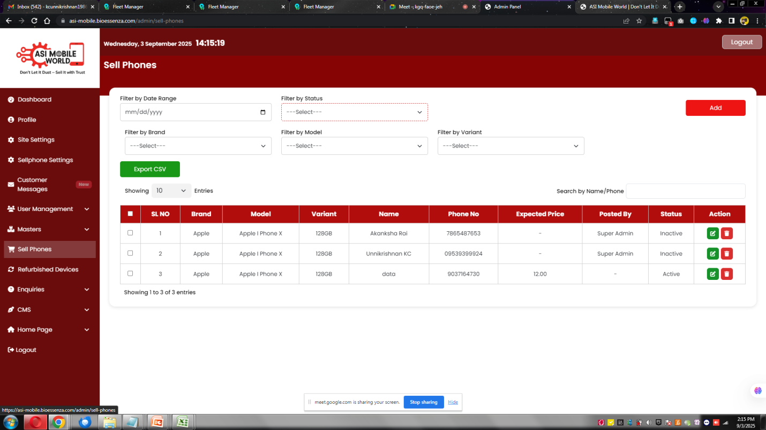
Sell Phones [20] New Blink
Status should change : Pending...
----Customer Details
----Device Details
--- Device Defects
---- Admin Review Comments
Is the Item Ready for Sale [] Yes []No
Put the Remarks : and the status will change to Rejected
Customer will get the email notification as well as a system notification on the above
Sell Phone : Reject List
It will move to that

If it is YEs
Status will be Verfied

Select the Address for Pick Up : Home- Office
Select the Date and Time for Pick UP :Select Date and Time

Update
Customer will get the email notification as well as a system notification on the above

Status to Collected , Refurbished
Add a new Status : Ready for Sale
Warrany Details :
Other Remarks :
Selling Price :
Save
-------------

The item from Sell Phones - Refurbished Devices

https://asi-mobile.bioessenza.com/admin/sell-phones
Same as like that
Action : Enquiry List
Sold Out .

